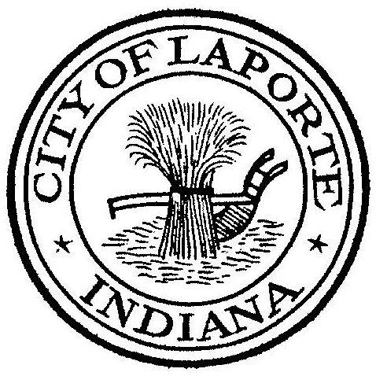
Board of Public Works and Safety
Jessica Romine, Member Tom Dermody, Mayor Mark Kosior, Member
City Hall 801 Michigan Ave., La Porte, IN 46350
Tuesday, March 5, 2024
9:00 AM
AGENDA
- Call To Order
- Pledge Of Allegiance
- Approval Of Minutes
- Public Comment: In Person and via Facebook Live
- Clerk-Treasurer: Claims Approval
- Department Head Reports
- New Business:
-Request for Use: Red Door
-Jerry Jackson: Industrial Wastewater Discharge Permit Renewal: Lewis Baking
-Dick Buell: Citizens Award-Anthony McClintock
-Tim Werner: Independent Contractor Agreement w/Todd Taylor
- Unfinished Business:
- Other Business: Next regularly scheduled meeting: Tuesday, March 19, 2024 at 9a
10) Adjourn

